

**Signals and Systems**

Lab Report#10

# Name:

Taha Saeed

**Registration number:**

FA18-EEE-032

**Submitted to:**

Dr. Ghufran Shafiq

**In-Lab Tasks**

**Task 01: The periodic signal is defined in one period as . Plot approximate signal using 81 terms of trigonometric form of Fourier series.**

**Solution:**

clear all;

clc;

T=6;

w=(2*pi)/T;

t1=0;

t2=6;

syms t

X=t.*exp(-t);

subplot(2,1,1);

ezplot(X,[t1,t2]);

title('original signal');

a0=(1/T).*int(X,t,t1,t2);

a0=vpa(a0);

n=1:80;

L1=X.*cos(n*w*t);

L2=X.*sin(n*w*t);

b=(2/T).*int(L1,t,t1,t2);

c=(2/T).*int(L2,t,t1,t2);

b=vpa(b); %b=double(b) can also be used but it has low precision

c=vpa(c); %c=double(c) can also be used but it has low precision

k=1:80;

a=a0+sum(b.*cos(k*w*t))+sum(c.*sin(k*w*t));

subplot(2,1,2);

ezplot(a,[t1,t2]);

title('using 81 coefficients');

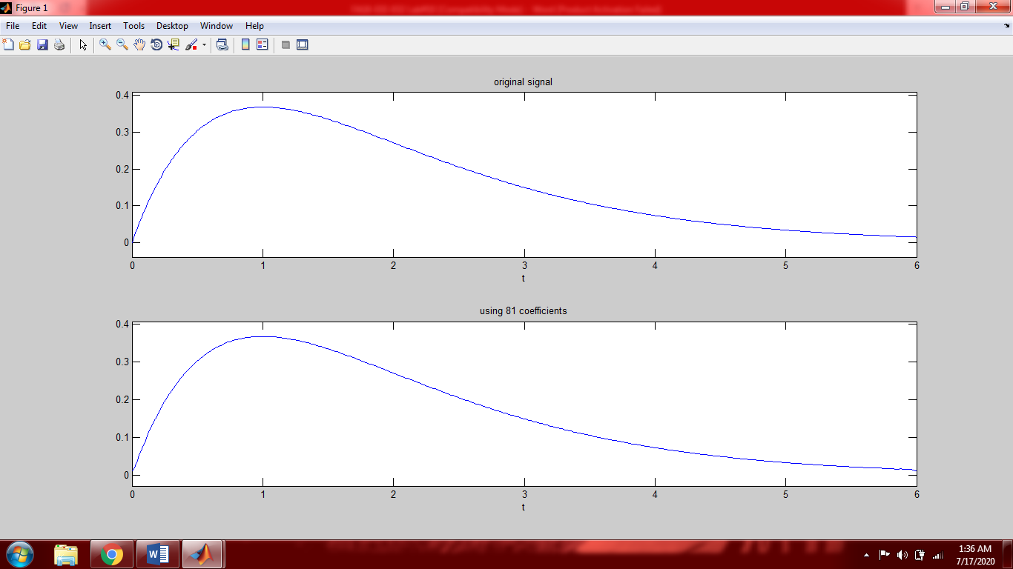

**Task 02: Plot the coefficients of the trigonometric Fourier series for the periodic signal that in one period is defined by .**

**Solution:**

clear all;

clc;

T=6;

t1=-3;

t2=3;

w=(2*pi)/T;

syms t

X=exp(-t.^2);

a0=(1/T).*int(X,t,t1,t2);

k=-3:3;

b=(2/T).*int(X.*cos(k*w*t),t,t1,t2);

c=(2/T).*int(X.*sin(k*w*t),t,t1,t2);

subplot(3,1,1);

stem(0,a0);

title('|a0|');

subplot(3,1,2);

stem(k,b);

title('|bk|');

subplot(3,1,3);

stem(k,c);

title('|ck|');

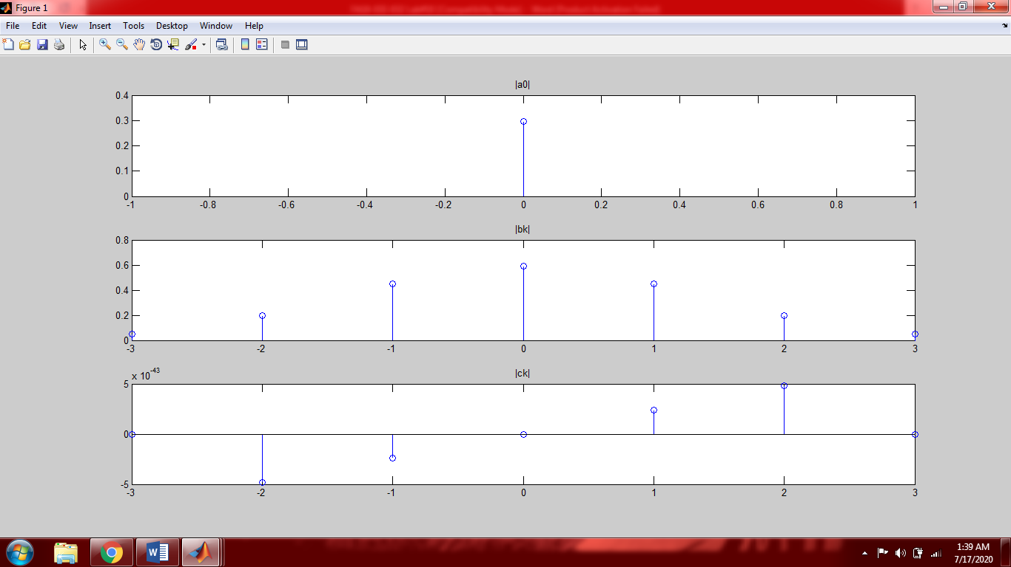

**Task 03: The periodic signal in a period is given by**



**Plot in one period the approximate signals using 41 and 201 term of the trigonometric Fourier series. Furthermore, each time plot the complex exponential coefficients.**

**Solution:**

clear all;

clc;

T=2;

w=(2*pi)/T;

t1=0;

t2=2;

syms t

X=heaviside(t)-heaviside(t-1);

figure(1)

subplot(3,1,1);

ezplot(X,[-1,3]);

title('original signal');

a0=(1/T).*int(X,t,t1,t2);

for n=1:40

b(n)=(2/T).*int(X.*cos(n*w*t),t,t1,t2);

c(n)=(2/T).*int(X.*sin(n*w*t),t,t1,t2);

end

k=1:40;

a=a0+sum(b.*cos(k*w*t))+sum(c.*sin(k*w*t));

subplot(3,1,2);

ezplot(a,[t1,t2]);

title('using 41 coefficients');

A0=(1/T).*int(X,t,t1,t2);

for n=1:200

B(n)=(2/T).*int(X.*cos(n*w*t),t,t1,t2);

C(n)=(2/T).*int(X.*sin(n*w*t),t,t1,t2);

end

k=1:200;

a=A0+sum(B.*cos(k*w*t))+sum(C.*sin(k*w*t));

subplot(3,1,3);

ezplot(a,[t1,t2]);

title('using 201 coefficients');

figure(2);

subplot(2,1,1)

stem(0,abs(a0));

title('|a0|');

subplot(2,1,2);

stem(0,angle(double(a0)));

title('<a0');

k=1:40;

figure(3);

subplot(2,1,1)

stem(k,abs(b));

title('|bk| for 41 terms');

subplot(2,1,2);

stem(k,angle(double(b)));

title('<bk for 41 terms');

figure(4);

subplot(2,1,1)

stem(k,abs(c));

title('|ck| for 41 terms');

subplot(2,1,2);

stem(k,angle(double(c)));

title('<ck for 41 terms')

k=1:200;

figure(5);

subplot(2,1,1)

stem(0,abs(A0));

title('|A0|');

subplot(2,1,2);

stem(0,angle(double(A0)));

title('<A0')

figure(6);

subplot(2,1,1)

stem(k,abs(B));

title('|bk for 201 terms|');

subplot(2,1,2);

stem(k,angle(double(B)));

title('<bk');

figure(7);

subplot(2,1,1)

stem(k,abs(C));

title('ck for 201 terms');

subplot(2,1,2);

stem(k,angle(double(C)));

title('<ck');

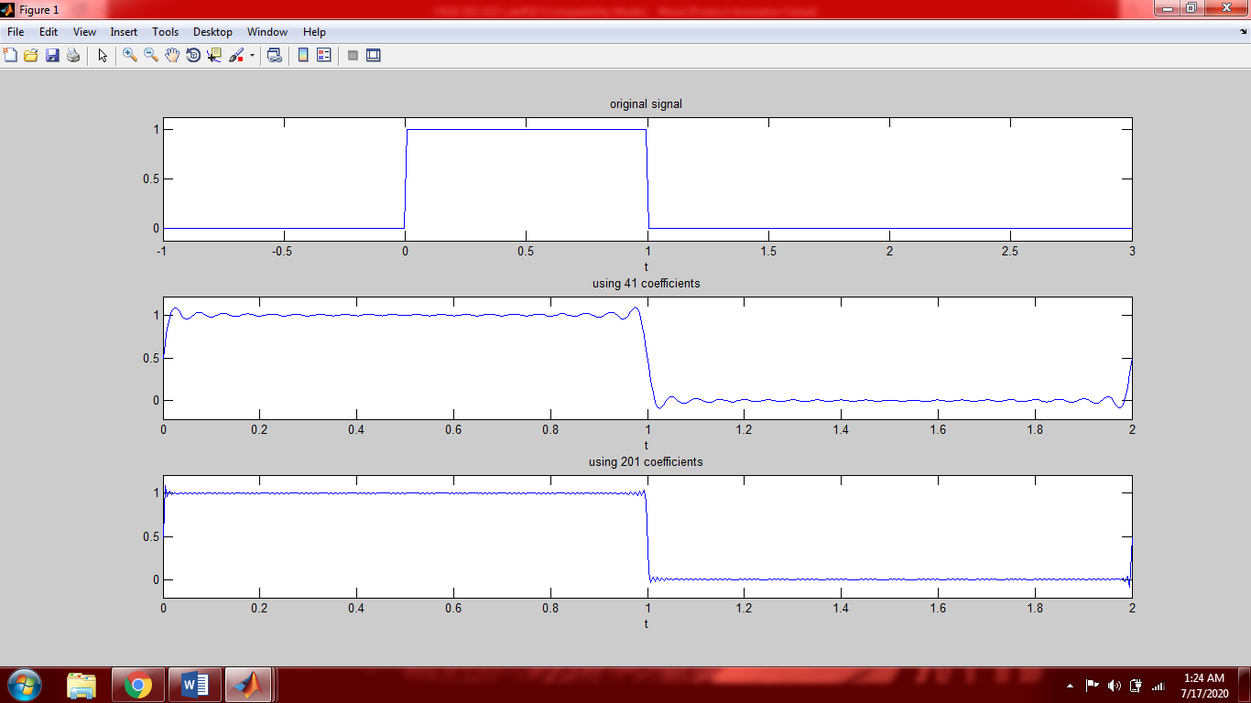

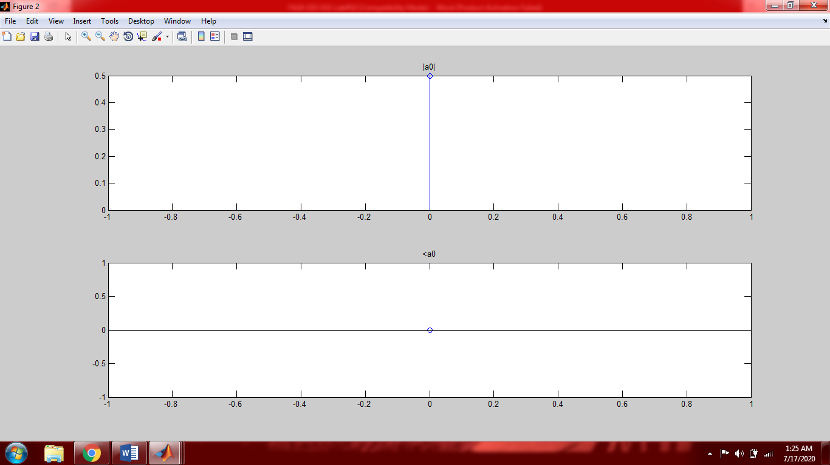

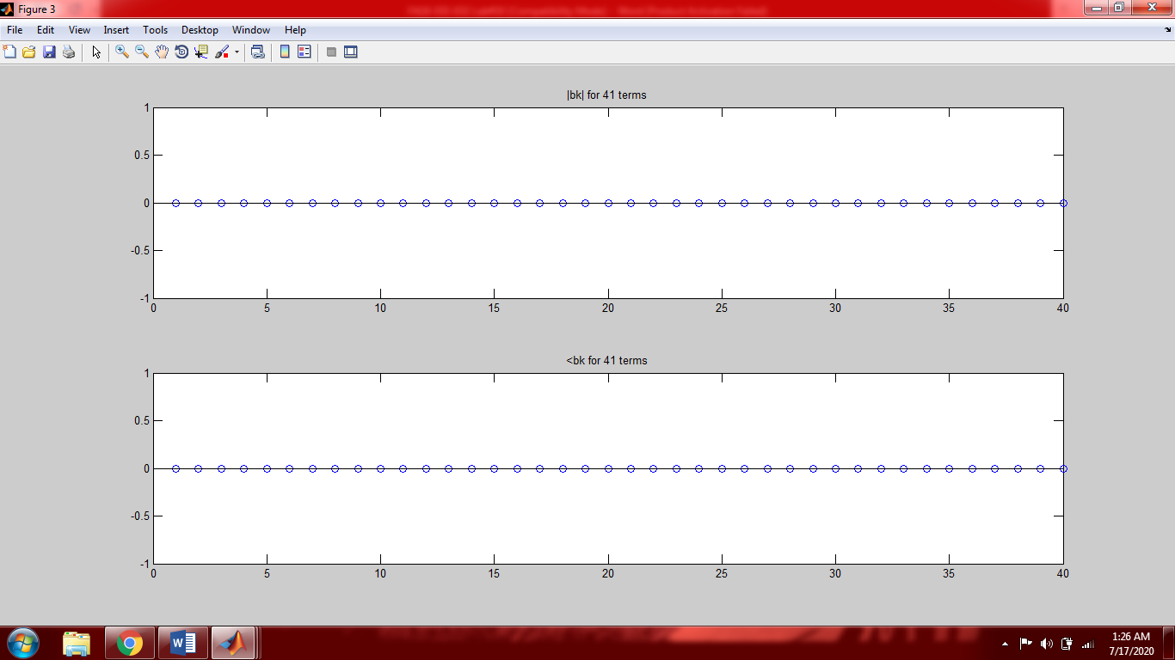

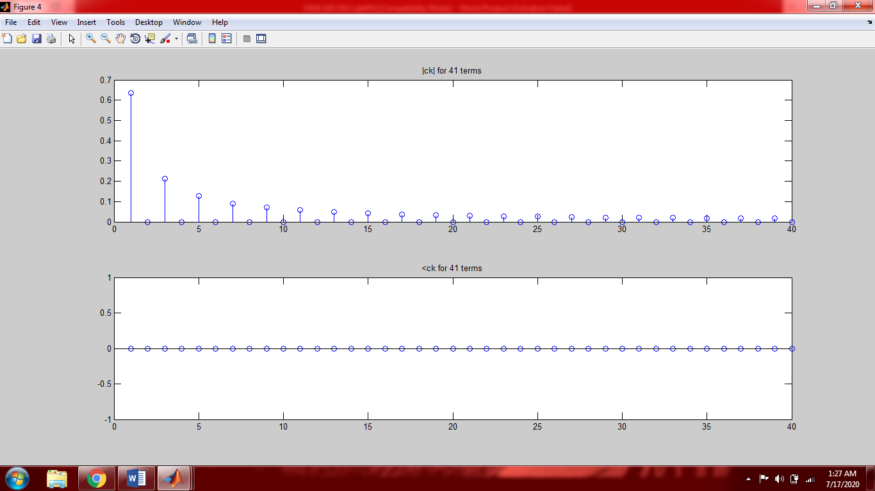

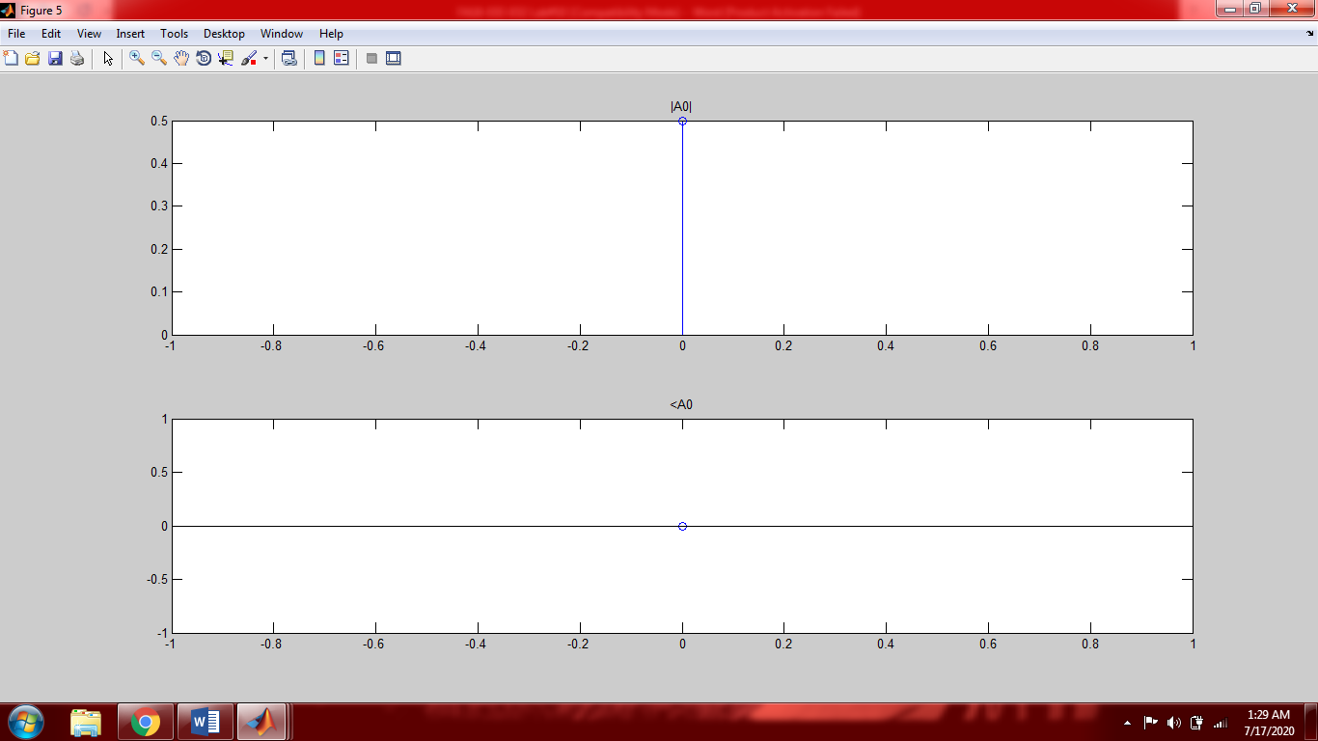

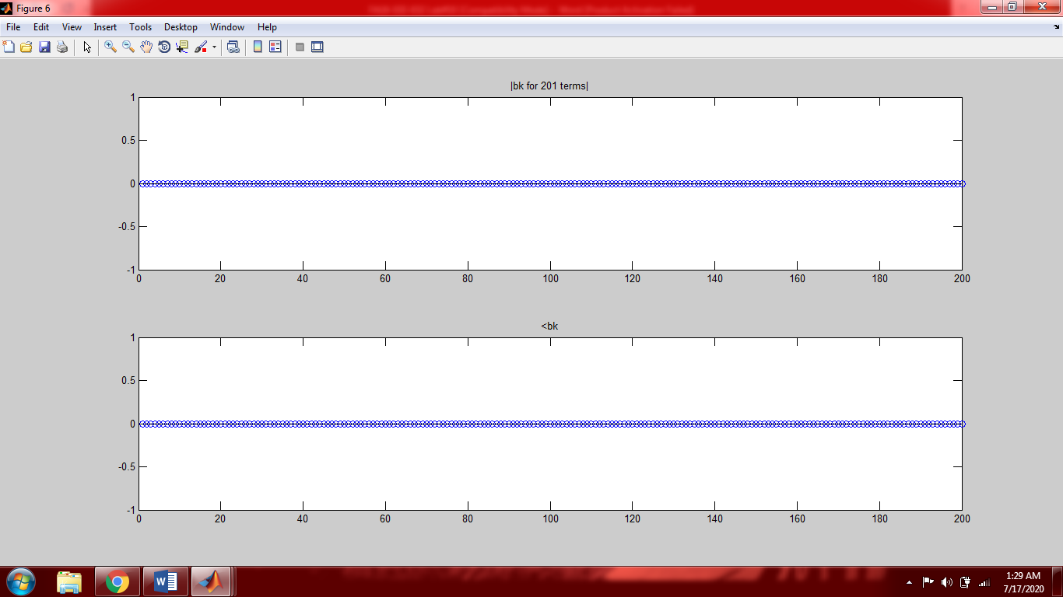

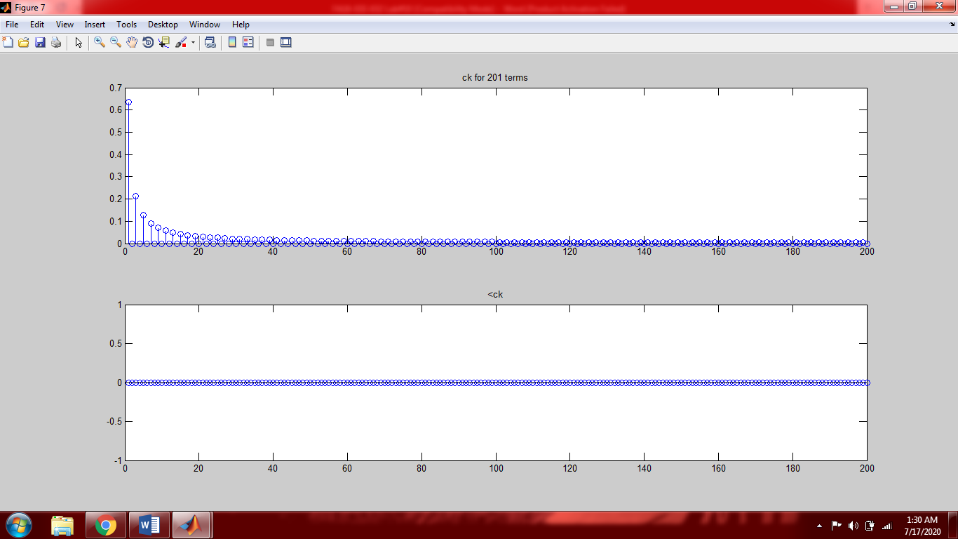

**Task 04: The periodic signal in a period is given by**



**Calculate the approximation percentage when the signal is approximated by 3, 5, 7, and 17 terms of the trigonometric Fourier series. Furthermore, plot the signal in each case.**

**Solution:**

clear all;

clc;

T=2;

w=(2*pi)/T;

t1=0;

t2=2;

syms t

X=(heaviside(t)-heaviside(t-1))+(2-t)*(heaviside(t-1)-heaviside(t-2));

figure(1)

ezplot(X,[-1,3]);

title('original signal');

Energy=int(abs(X).^2,t,t1,t2);

a0=(1/T).*int(X,t,t1,t2);

for n=1:2

b(n)=(2/T).*int(X.*cos(n*w*t),t,t1,t2);

c(n)=(2/T).*int(X.*sin(n*w*t),t,t1,t2);

end

k=1:2;

a=a0+sum(b.*cos(k*w*t))+sum(c.*sin(k*w*t));

figure(2);

subplot(2,2,1);

ezplot(a,[t1,t2]);

title('using 3 coefficients');

Energy1=int(abs(a).^2,t,t1,t2);

perror1=(abs(Energy-Energy1))/Energy;

perror1=double(perror1)*100;

Approximation1=100-perror1

for n=1:4

b(n)=(2/T).*int(X.*cos(n*w*t),t,t1,t2);

c(n)=(2/T).*int(X.*sin(n*w*t),t,t1,t2);

end

k=1:4;

a=a0+sum(b.*cos(k*w*t))+sum(c.*sin(k*w*t));

figure(2);

subplot(2,2,2);

ezplot(a,[t1,t2]);

title('using 5 coefficients');

Energy2=int(abs(a).^2,t,t1,t2);

perror2=(abs(Energy-Energy2))/Energy;

perror2=double(perror2)*100;

Approximation2=100-perror2

for n=1:6

b(n)=(2/T).*int(X.*cos(n*w*t),t,t1,t2);

c(n)=(2/T).*int(X.*sin(n*w*t),t,t1,t2);

end

k=1:6;

a=a0+sum(b.*cos(k*w*t))+sum(c.*sin(k*w*t));

figure(2);

subplot(2,2,3);

ezplot(a,[t1,t2]);

title('using 7 coefficients');

Energy3=int(abs(a).^2,t,t1,t2);

perror3=(abs(Energy-Energy3))/Energy;

perror3=double(perror3)*100;

Approximation3=100-perror3

for n=1:16

b(n)=(2/T).*int(X.*cos(n*w*t),t,t1,t2);

c(n)=(2/T).*int(X.*sin(n*w*t),t,t1,t2);

end

k=1:16;

a=a0+sum(b.*cos(k*w*t))+sum(c.*sin(k*w*t));

figure(2);

subplot(2,2,4);

ezplot(a,[t1,t2]);

title('using 17 coefficients');

Energy4=int(abs(a).^2,t,t1,t2);

perror4=(abs(Energy-Energy4))/Energy;

perror4=double(perror4)*100;

Approximation4=100-perror4

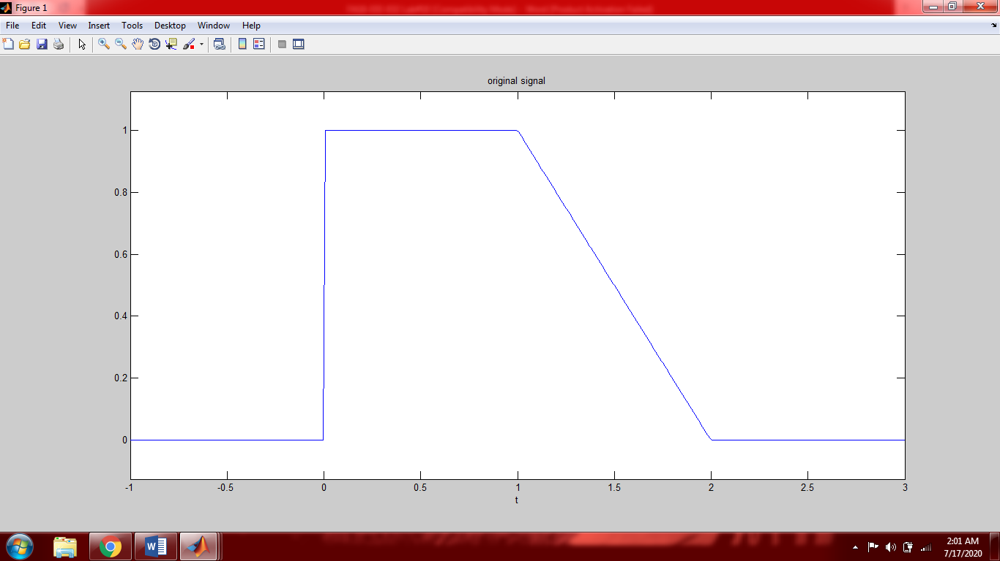

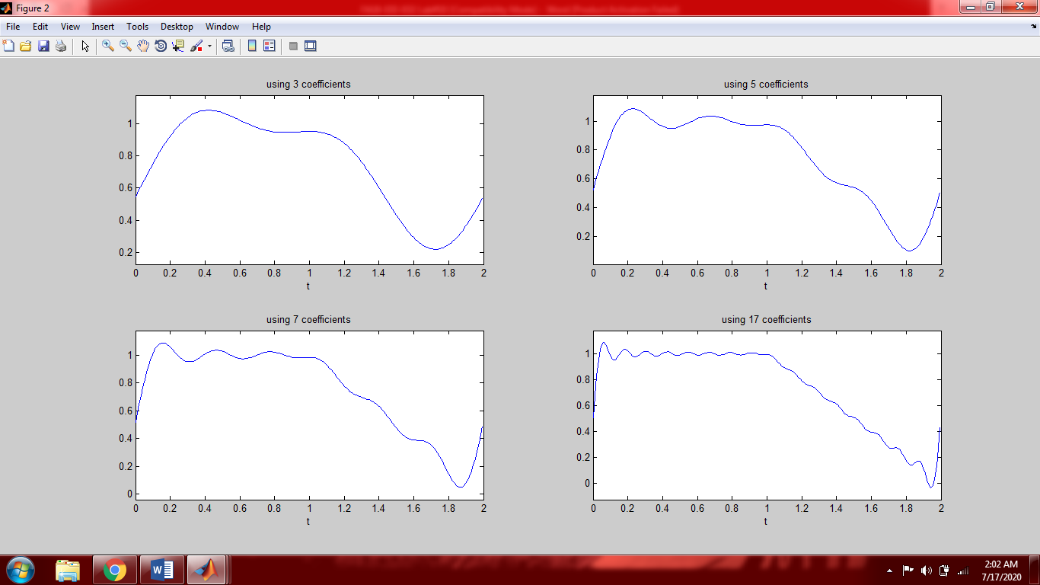

**Results:**

Approximation1 =96.9537

Approximation2 =98.3110

Approximation3 =98.8309

Approximation4 =99.5395

As can be seen from the above results the approximation percentage increase by increasing the number of terms of the trigonometric Fourier series. (Approximated signal becomes more and more equal to original signal by increasing the terms of trigonometric Fourier series)

**Post-Lab Task**

## Critical Analysis / Conclusion

|  |
| --- |
| In this lab we proved that a periodic signal can be represented in the form of trigonometric Fourier series.  By increasing the terms of trigonometric Fourier series the signal becomes more approximate to the original signal (becomes more equal to original signal).  To save time we can increase the speed of our code by changing symbolic date type to **double precision** date type or variable precision (**vpa**).  I prefer variable precision (**vpa**) over **double precision** because we can control the precision of our calculations by using the **digit()** command and minimize the effect of round off errors. |